**USER MANUAL**

**OF**

**DEAKIN UNIVERSITY ANDROID APPLICATION**

Table of Contents

About This Guide 3

Audience 3

Overview of the App 3

Getting Started 4

Home Page 4

Login Page 6

Mentee Registration Page 7

Mentor Registration Page 8

Staff Home Page 9

Staff Add Event Page 10

Staff Upcoming Event Page 11

Staff Add Resource Page 12

Staff Sent Survey Link Page 13

Staff Manage User Page 14

Staff Manage Mentee 15

Staff Manage Mentor 16

# 

# About This Guide

This user manual provides the information about the functionalities as well as the feature available for DEAKIN UNIVERSITY Android Application and the ways to access them for a user.

# Audience

This user manual is intended for people who want to use their Android phone to access remote interactive services for their own usage purpose.

# Overview of the App

This android application is based on the functionalities made for Mentee Mentor platform where all types of required features are accessible under a single application. There is another user who is a Staff who acts like an Admin for this application. This means that the Staff type user has all the provision to access Mentee Mentor data and manages group, data and assets etc. Mentee and Mentor individually get notified if Staff adds something or any Group Chat is being performed by other group members.

# Getting Started

## Home Page

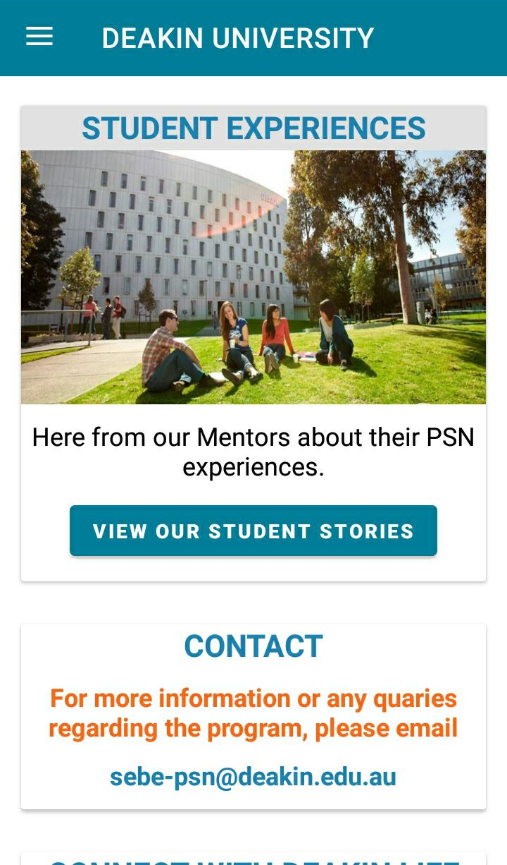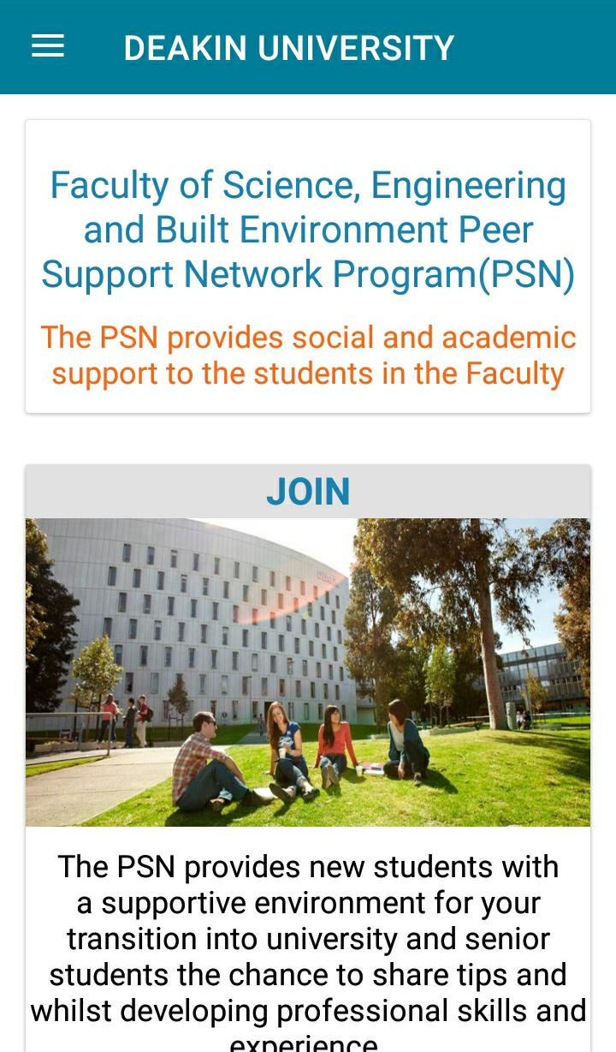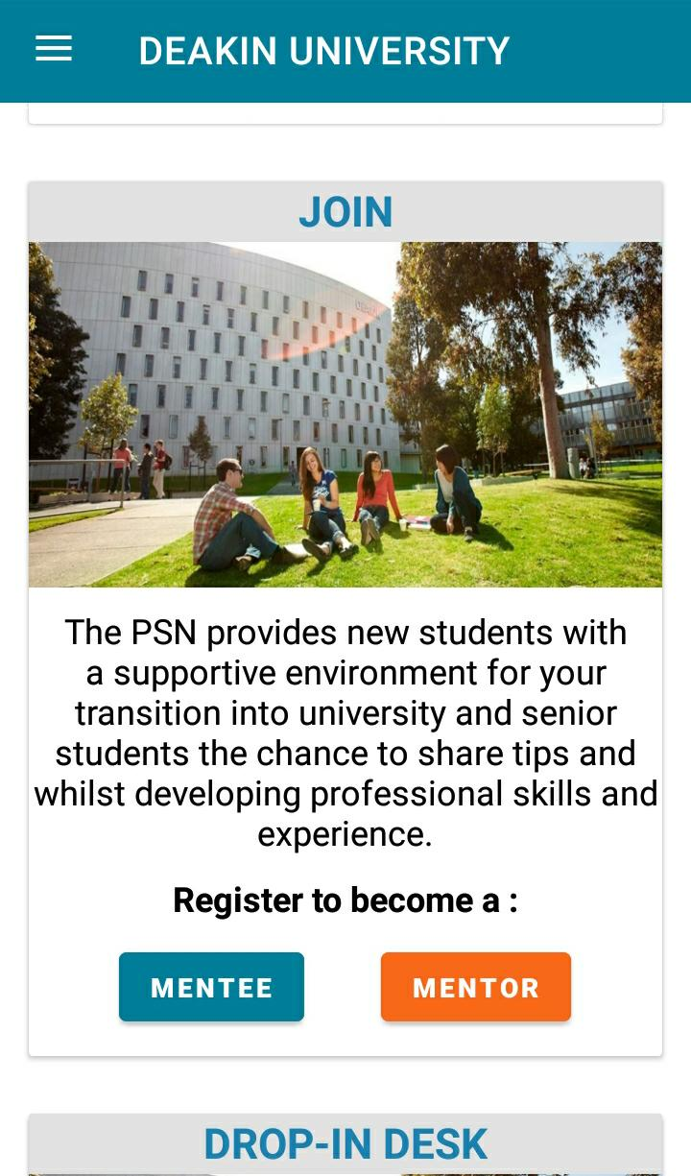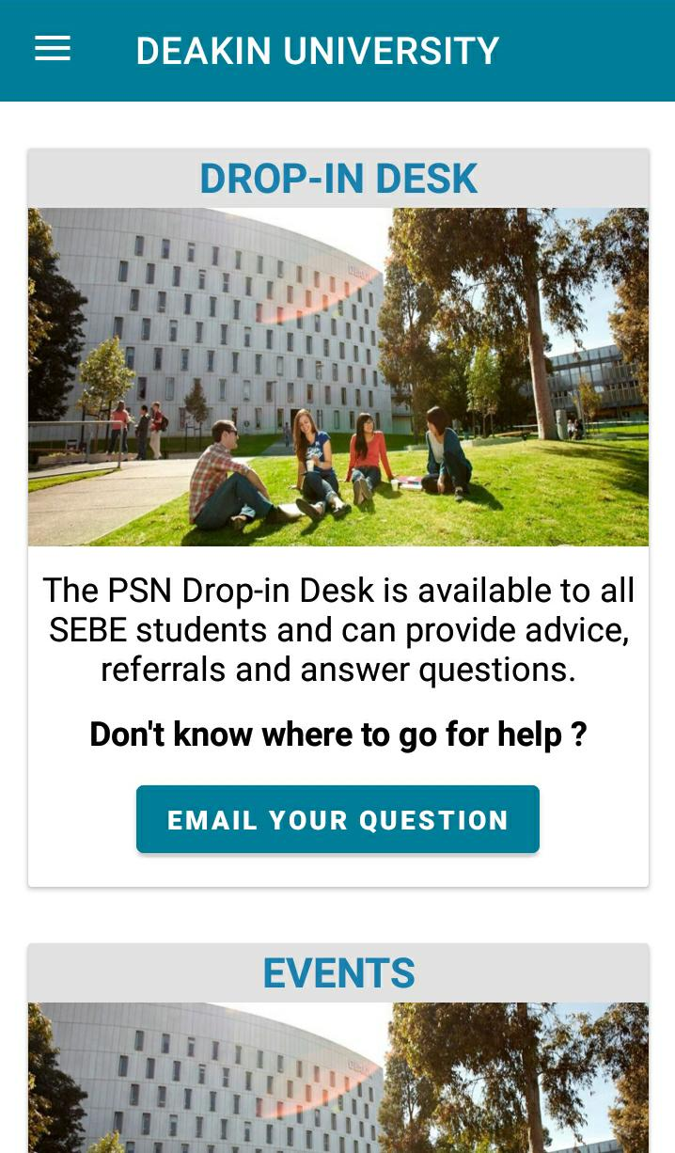

## C:\Users\arnab\AppData\Local\Temp\Rar$DRa11352.49468\WhatsApp Image 2021-02-14 at 1.50.08 AM (1).jpegC:\Users\arnab\AppData\Local\Temp\Rar$DRa11352.49468\WhatsApp Image 2021-02-14 at 1.50.07 AM (1).jpeg

## 

## Login Page

## C:\Users\arnab\AppData\Local\Temp\Rar$DRa11352.49468\WhatsApp Image 2021-02-14 at 1.50.00 AM.jpegC:\Users\arnab\AppData\Local\Temp\Rar$DRa11352.49468\WhatsApp Image 2021-02-14 at 1.50.00 AM (1).jpeg

## 

## Mentee Registration Page

## C:\Users\arnab\AppData\Local\Temp\Rar$DRa11352.49468\WhatsApp Image 2021-02-14 at 1.50.07 AM.jpeg C:\Users\arnab\AppData\Local\Temp\Rar$DRa11352.49468\WhatsApp Image 2021-02-14 at 1.50.01 AM.jpeg

## 

## Mentor Registration Page

## C:\Users\arnab\AppData\Local\Temp\Rar$DRa11352.49468\WhatsApp Image 2021-02-14 at 1.50.01 AM (1).jpeg C:\Users\arnab\AppData\Local\Temp\Rar$DRa11352.49468\WhatsApp Image 2021-02-14 at 1.50.03 AM.jpeg

## 

## Staff Home Page

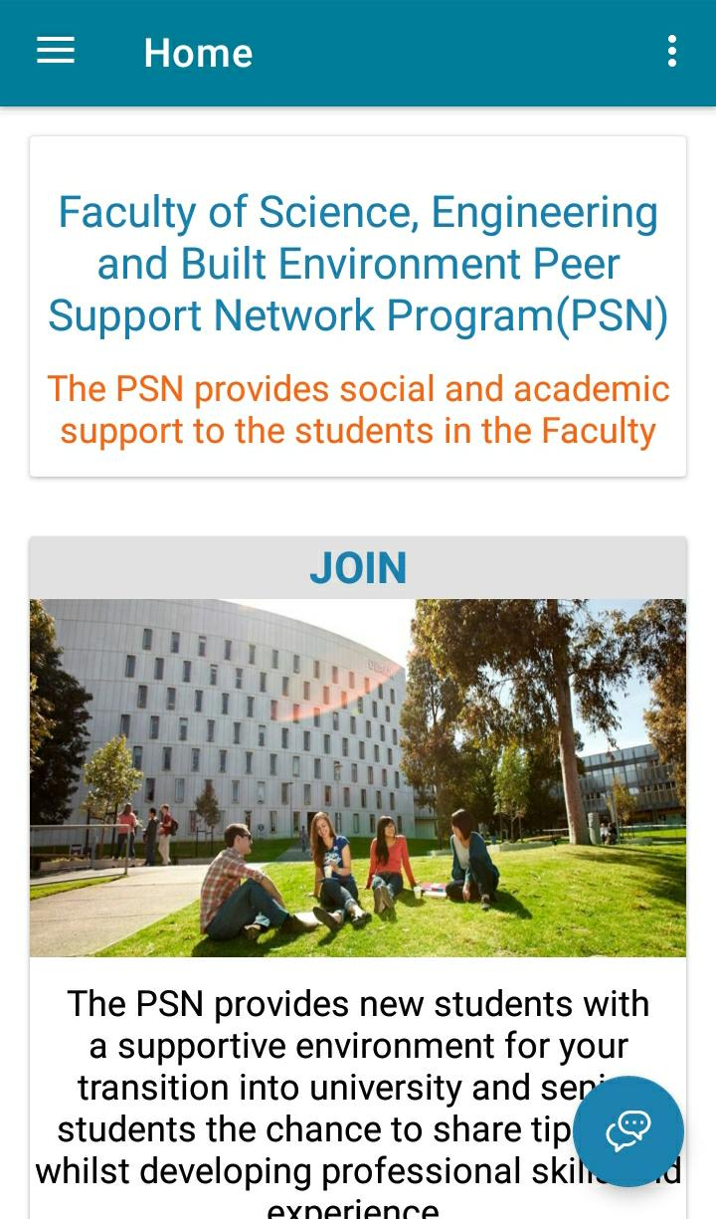 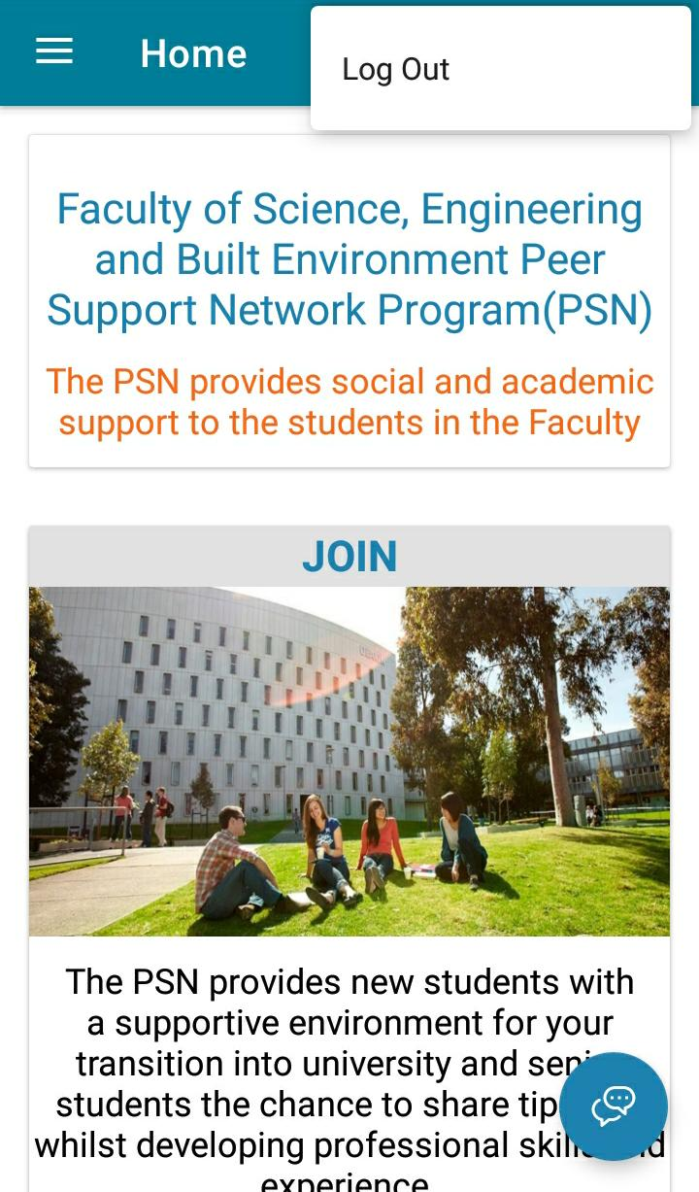 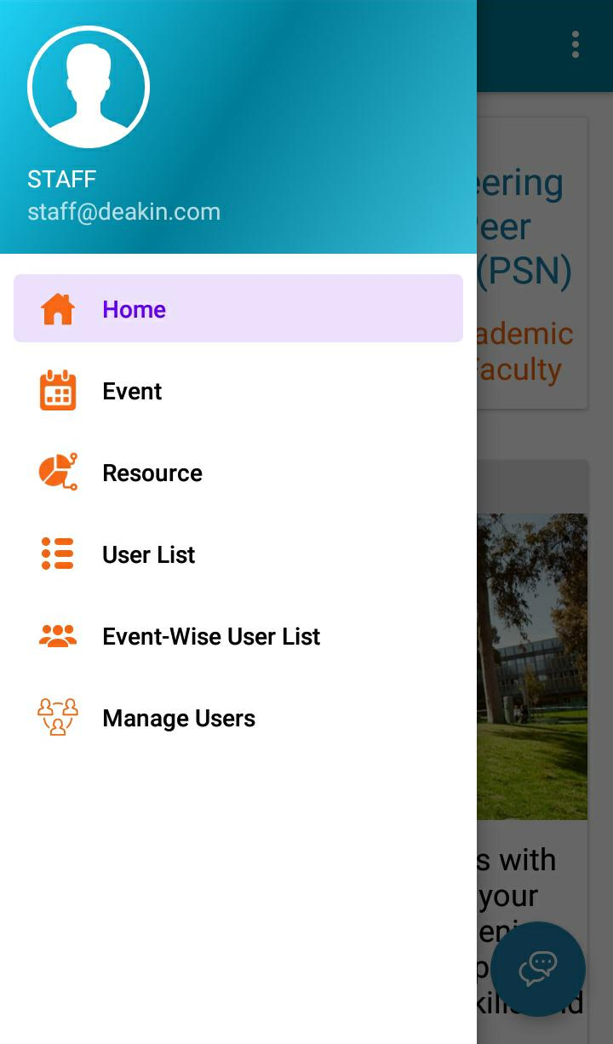

## Staff Add Event Page

## C:\Users\arnab\AppData\Local\Temp\Rar$DRa8772.9797\WhatsApp Image 2021-02-14 at 2.14.23 AM.jpeg C:\Users\arnab\AppData\Local\Temp\Rar$DRa8772.9797\WhatsApp Image 2021-02-14 at 2.14.22 AM (2).jpeg

## 

## Staff Upcoming Event Page

## C:\Users\arnab\AppData\Local\Temp\Rar$DRa8772.9797\WhatsApp Image 2021-02-14 at 2.14.22 AM (1).jpeg

## 

## Staff Add Resource Page

## C:\Users\arnab\AppData\Local\Temp\Rar$DRa8772.9797\WhatsApp Image 2021-02-14 at 2.14.22 AM.jpeg

## 

## Staff Sent Survey Link Page

## C:\Users\arnab\AppData\Local\Temp\Rar$DRa8772.9797\WhatsApp Image 2021-02-14 at 2.14.16 AM (1).jpeg C:\Users\arnab\AppData\Local\Temp\Rar$DRa8772.9797\WhatsApp Image 2021-02-14 at 2.14.16 AM.jpeg

## 

## Staff Manage User Page

## C:\Users\arnab\AppData\Local\Temp\Rar$DRa8772.9797\WhatsApp Image 2021-02-14 at 2.14.15 AM (1).jpeg

## 

## Staff Manage Mentee

## C:\Users\arnab\AppData\Local\Temp\Rar$DRa8772.9797\WhatsApp Image 2021-02-14 at 2.14.15 AM.jpeg

## 

## Staff Manage Mentor

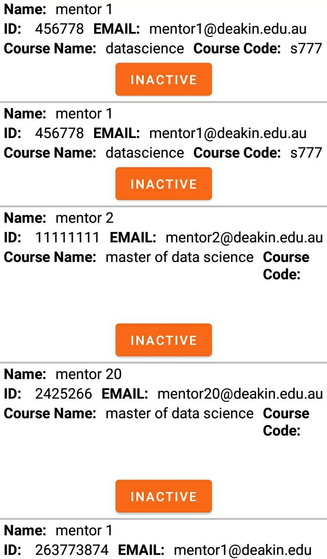

## Staff Event Wise User List

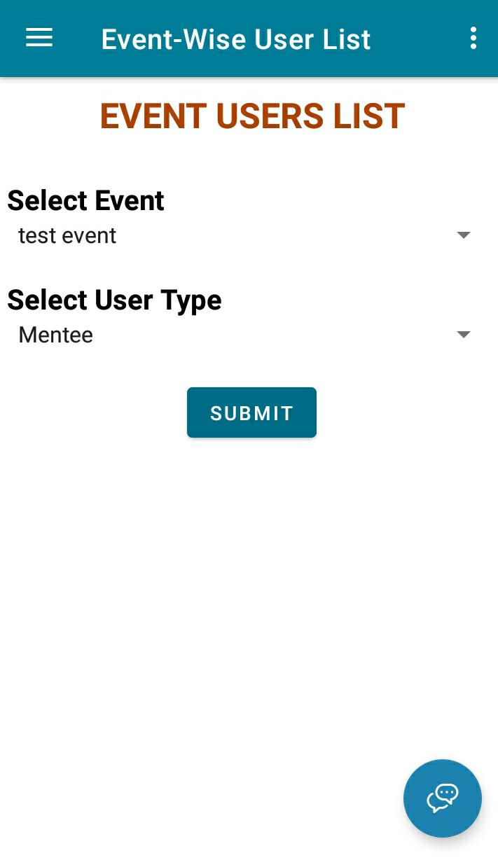

## Staff Create Group

